**PL_SQL APEX PRACTICE TRIGGERS**

## G Nithin Kumar

## 192325048

## Write a code in PL/SQL to develop a trigger that enforces referential integrity by preventing the deletion of a parent record if child records exist.

### Create departments table:

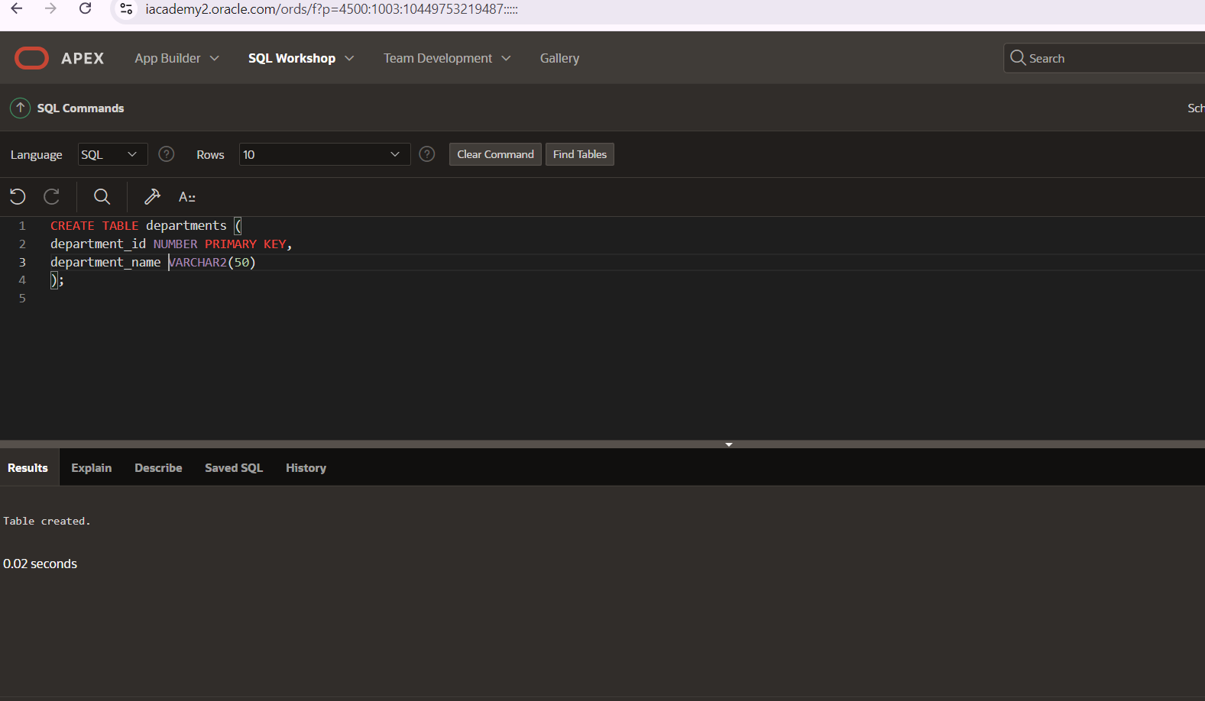

### Create the 'employeess’ table with a foreign key reference

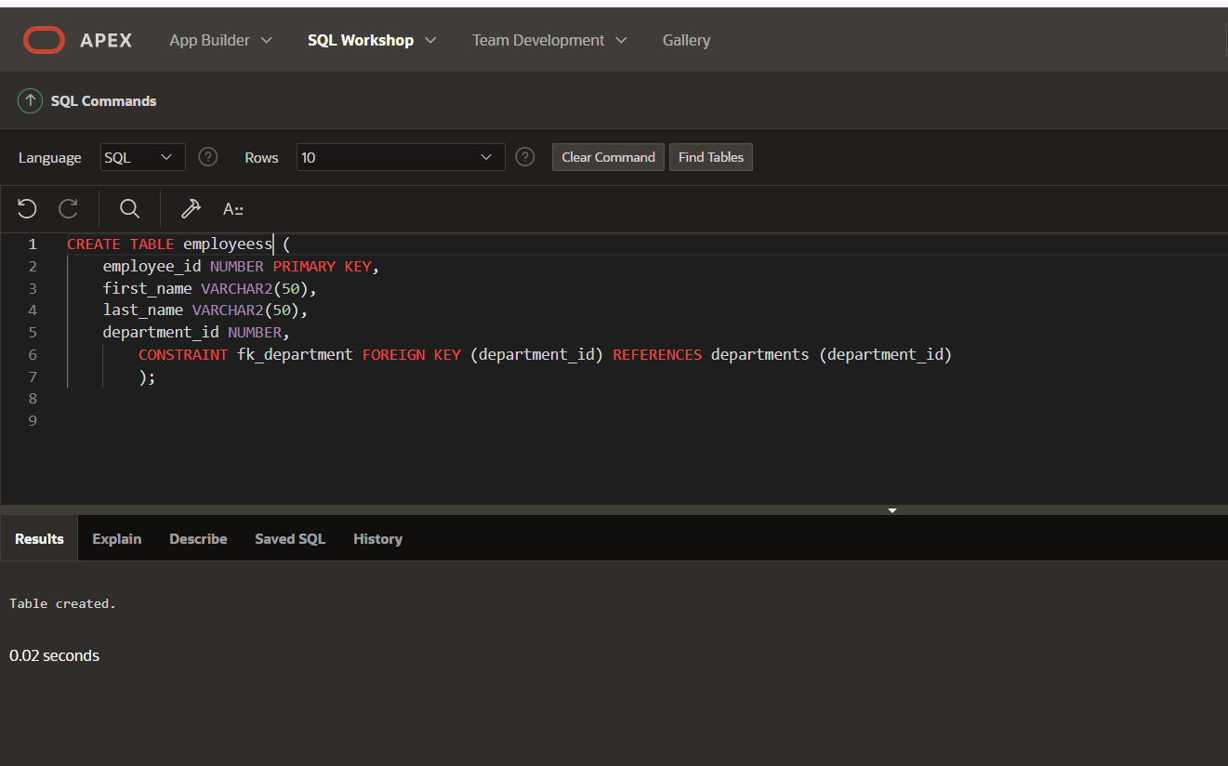

### Create a trigger to enforce referential integrity

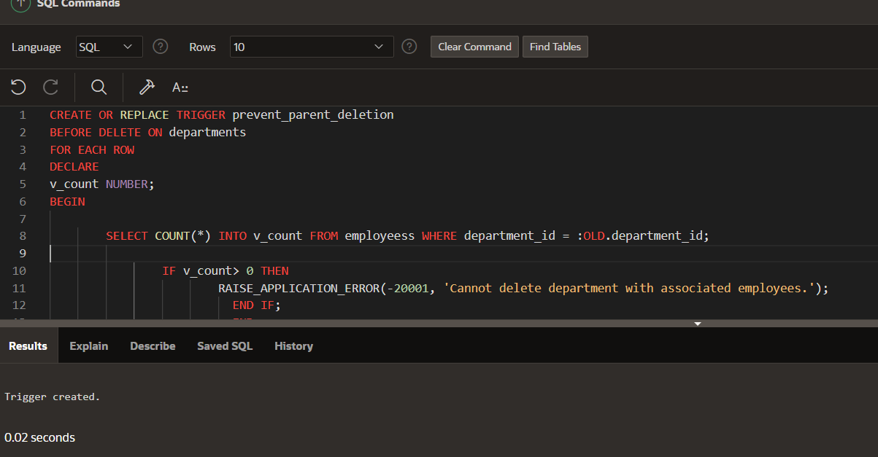

## Write a code in PL/SQL to create a trigger that checks for duplicate values in a specific column and raises an exception if found.

### Add a column email to the employeess table

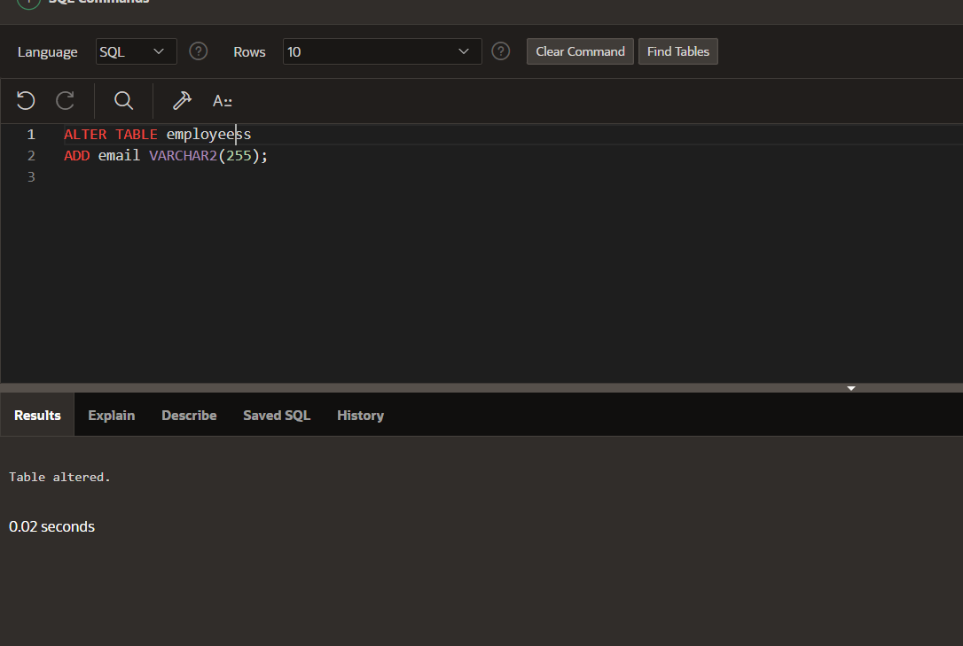

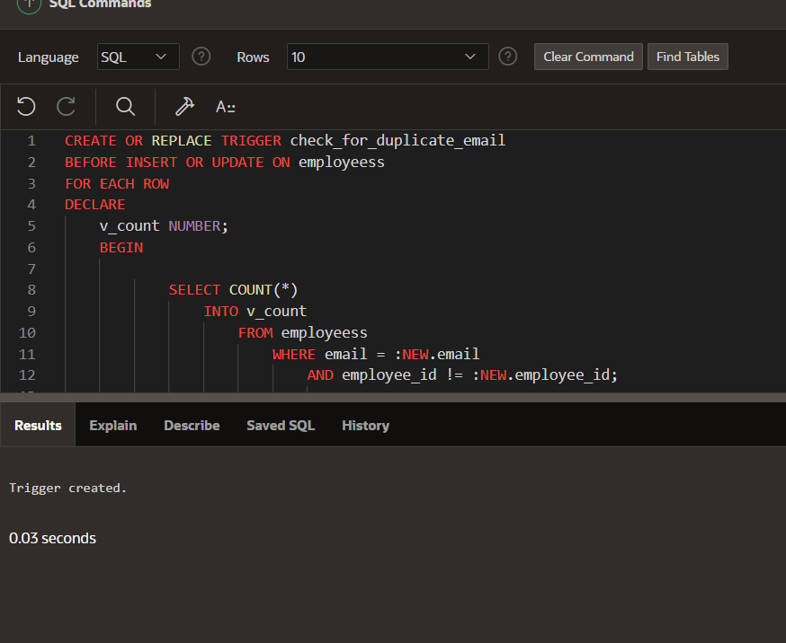

## 3rd

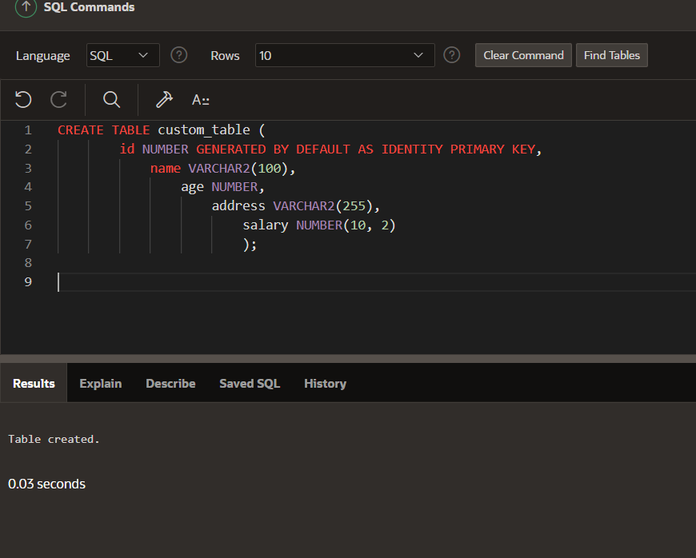

## Exception handling

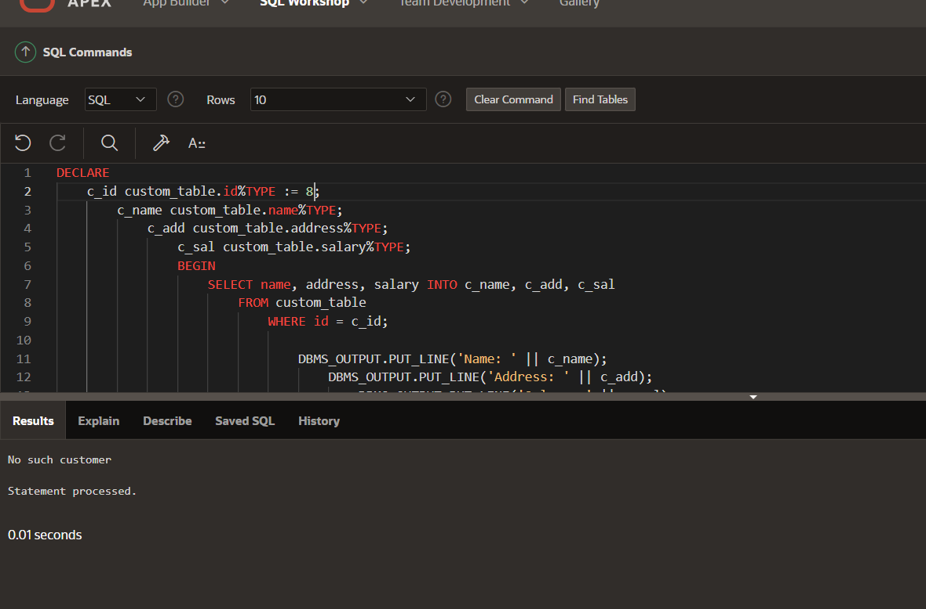

## Write a PL/SQL block to handle the exception when a division by zero occurs

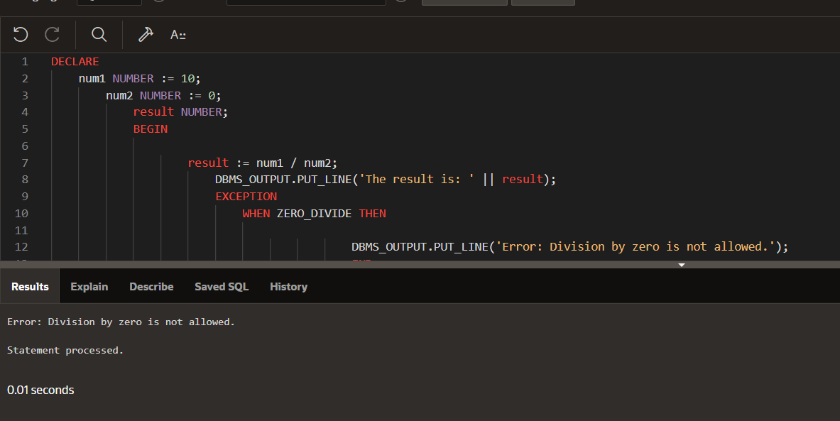

## Handle the INVALID_NUMBER exception when converting a non-numeric value to a number.

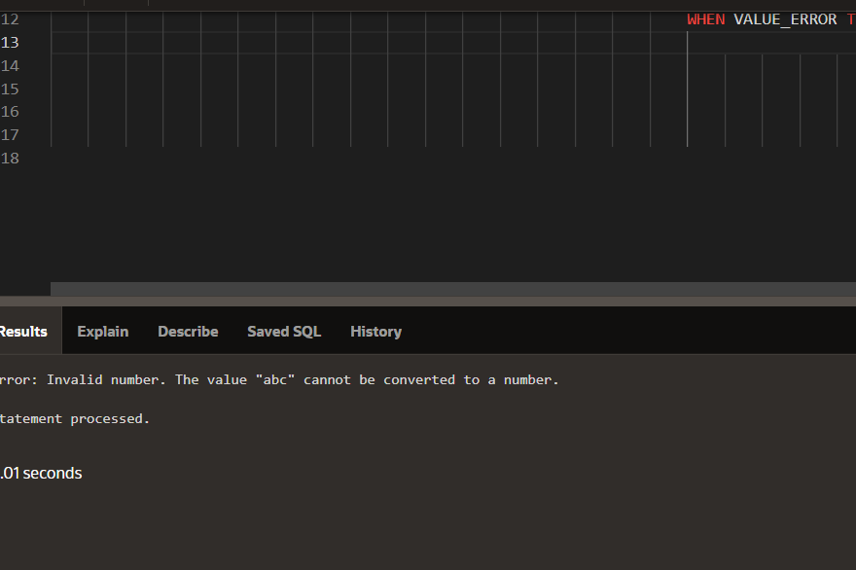

## Handle the NO_DATA_FOUND exception when retrieving a row from a table and no matching record is found.

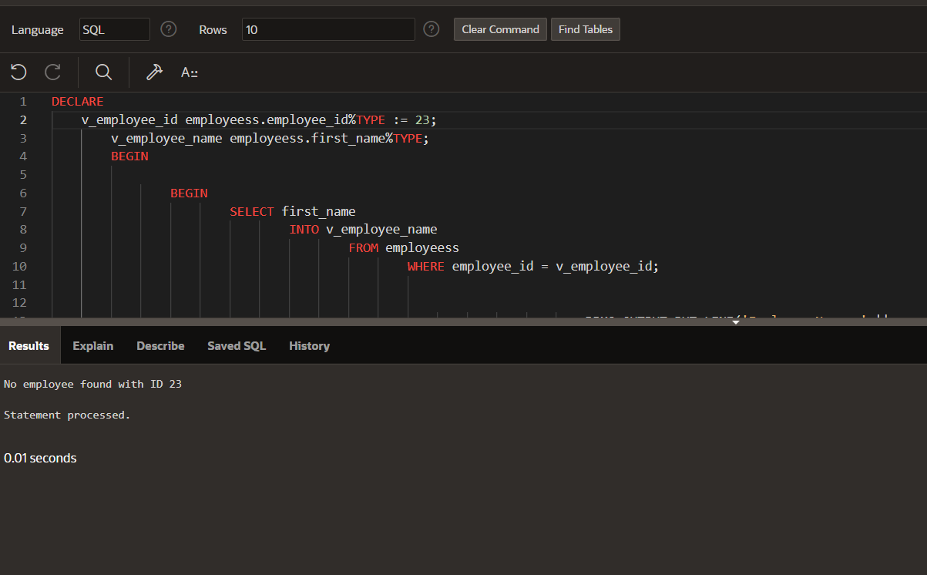

## Handle the TOO_MANY_ROWS exception when retrieving multiple rows instead of a single row from a table.

